|  |  |  |  |
| --- | --- | --- | --- |
| **Input** | **Expected Output** | **Actual Output** | **Pass?** |
| Iterative, n = 0  Recursive, n = 0 | Result: 0, Efficiency: 1  Result: 0, Efficiency: 1 | Result: 0, Efficiency: 1  Result: 0, Efficiency: 1 | Yes |
| Iterative, n = -3  Iterative, n = 3  Recursive, n = 3 | “Please enter a positive integer.”  Result: 5, Efficiency: 4  Result: 5, Efficiency: 5 | “Please enter a positive integer”  Result: 5, Efficiency: 4  Result: 5, Efficiency: 5 | Yes |
| Iterative, n = 5.8  Iterative, n = 5  Recursive, n = 5 | “Please enter a valid integer.”  Result: 29, Efficiency: 6  Result: 29, Efficiency: 15 | “Please enter a valid integer.”  Result: 29, Efficiency: 6  Result: 29, Efficiency: 15 | Yes |
| Iterative, n = h  Iterative, n = 8  Recursive, n = 8 | “Please enter a valid integer.”  Result: 408, Efficiency: 9  Result: 408, Efficiency: 67 | Please enter a valid integer.”  Result: 408, Efficiency: 9  Result: 408, Efficiency: 67 | Yes |
| Iterative, n = 10  Recursive, n = 10 | Result: 2378, Efficiency: 11  Result: 2378, Efficiency: 177 | Result: 2378, Efficiency: 11  Result: 2378, Efficiency: 177 | Yes |

Screen Capture of me successfully compiling and executing my Java program:



**Screen Captures of Test Case #1:**

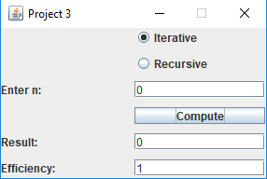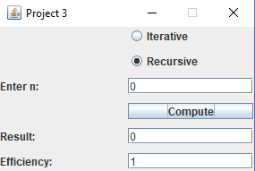

**Screen Captures of Test Case #2:**

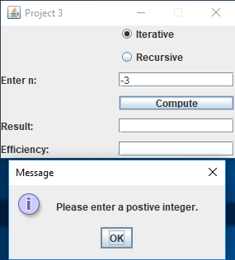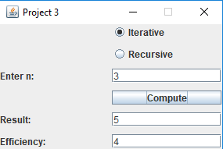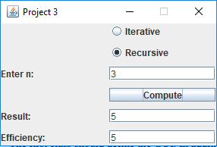

**Screen Captures of Test Case #3:**

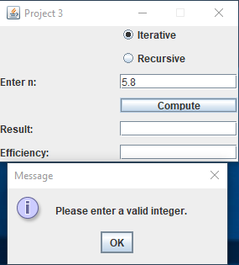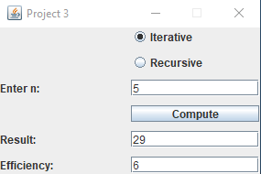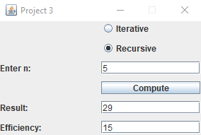

**Screen Captures of Test Case #4:**

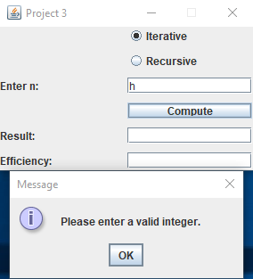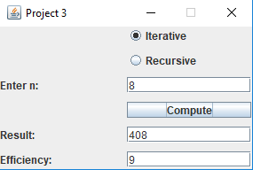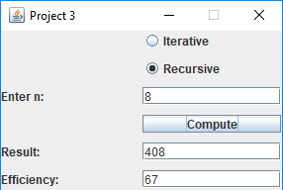

**Screen Captures of Test Case #5:**

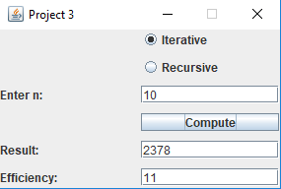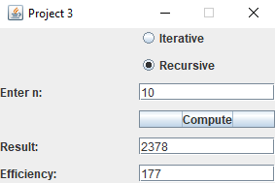

**Picture of “Efficiency Values .csv” file that saves after closing out of program:**

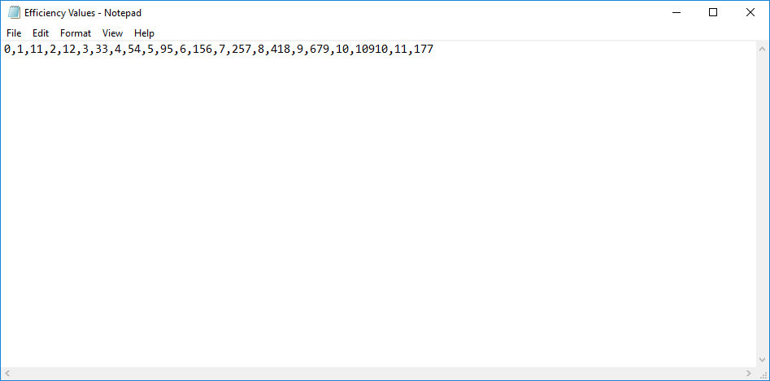

**Picture of Graph produced in Excel showing Efficiency Value vs. nth Term:**

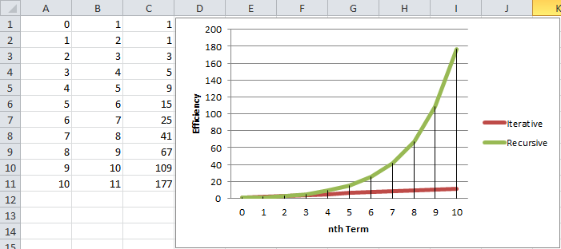

**Observed Results:**

It only takes one quick glance at the graph to see that as number of terms in the sequence increases, the larger the difference in efficiency between the iterative and recursive methods of computation for this sequence of numbers. There is however one case when n = 1, that the efficiency of the iterative method (2) is greater than the recursive method (1).